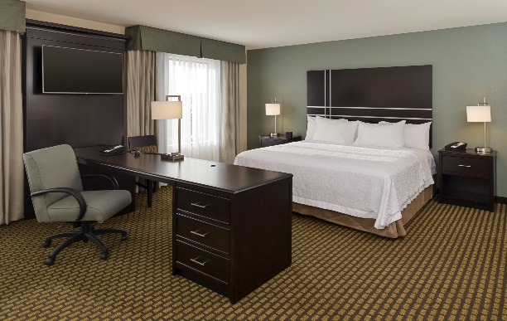

King Non-Smoking Suite
Reg: $269.00
Your Price: $114.00

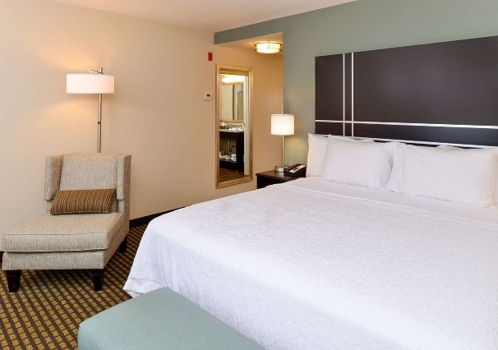

Standard Non-Smoking King
Reg: $259.00
Your Price: $ 104.00

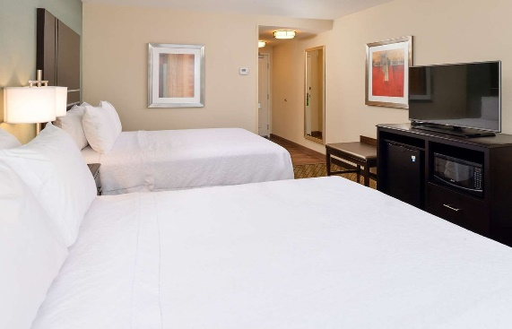
Standard Non-Smoking Double Queen
Reg: $259.00
Your Price: $ 104.00

